For those who choose to approach St. Michaels from the Miles River, there are also several options for where to drop the hook. On a busy weekend, quite a few boats will anchor to the east of G “3” in the Miles River itself. It is not as well protected from wind and wake as other locations, but few of the people who anchor there seem to mind. Fogg Cove, on the north side of the harbor is where we stayed on our most recent visit. It provides space for about a dozen boats, but can get a bit tight. Here you need to make sure you stay far enough off the docks that line the water and watch out for the channel markers. To the south, within the harbor proper, lies another anchorage with good holding and room for 6-10 boats. This spot is the closest to St. Michaels itself and, being inside the harbor, sees very little wake. For those looking for more seclusion, Long Haul Creek, about a mile to the north just off the Miles offers good protection surrounded by a few homes and the Miles River Yacht Club. We love it there, but it is also a long, alm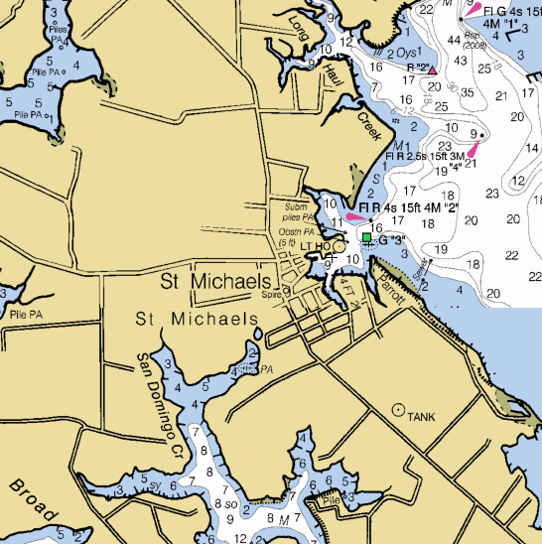ost prohibitive, walk or dinghy ride into St. Michaels.
To go ashore, the town provides a nice floating dinghy dock just inside of the Crab Claw Restaurant, as well as the aforementioned dinghy dock on San Domingo Creek. Up the street from the dock is an Acme supermarket, which is a great place to provision. The public library and Blue Crab Coffee sit just beyond the supermarket, offering free internet, tolerance for the loitering cruiser, and, in the case of the latter, good java. Great bars, restaurants, and ice cream parlors line the streets, offering lots of fine choices. Ava’s Pizzeria and Wine Bar is known for excellent pies and a solid wine selection. Right next door is Theo’s, which specializes in all things meat, but also offers some seafood dishes. We had a fabulous dinner at Gina’s Café, an eclectic Mexican place with a great atmosphere. Of course, the Crab Claw and St. Michael’s Crab and Steak House are both institutions, right on the water. Carpenter Street Saloon, affectionately known as C-Street, is the locals’ hangout that is regularly invaded by visitors, who are then treated like regulars. Foxy’s Grille is a far cry from its BVI namesake, but does offer an open-air bar right on the water.

